1. **Agenda**:
   1. We will publish the JSON message to a queue from our Java App.
2. Let’s add dependency.  
   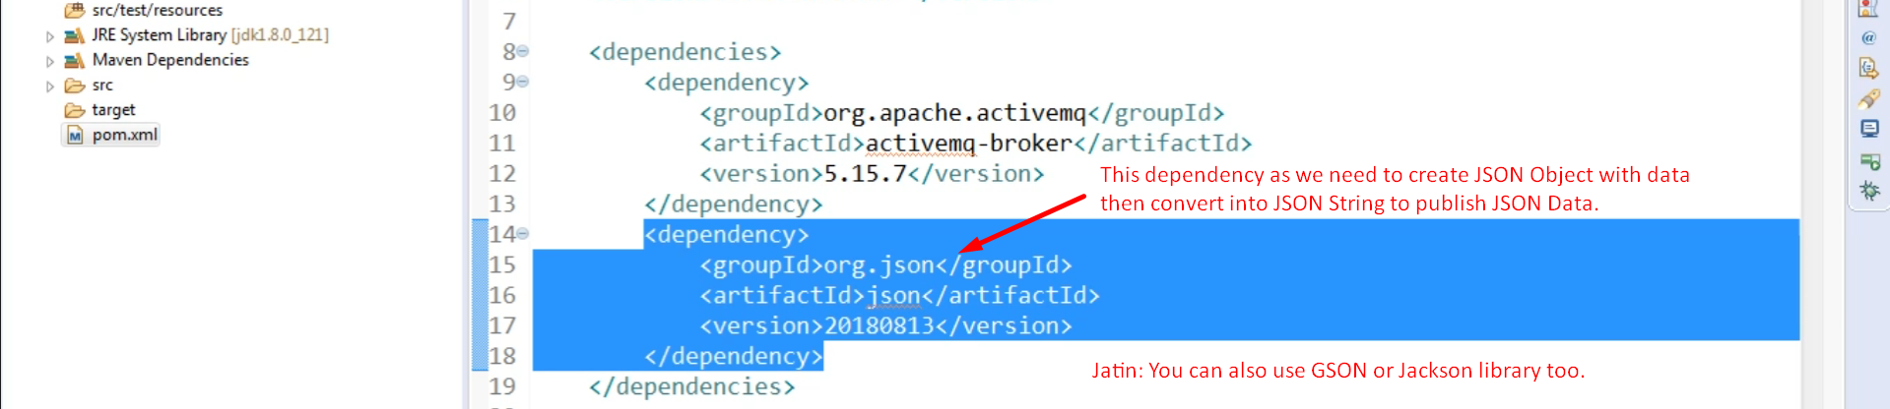
3. Creating JSON data, publishing it.  
   Graphical user interface, text, application, email

   Description automatically generated
4. Graphical user interface, text, application, email

   Description automatically generated